**Create Blog Page**

**Send Feedback**

Now, you know what is heading tag and paragraph tag and how and where to use them.

So, let's make use of them to add content to our blog page.

All the content to be added is provided inside the HTML itself.

NOTE: For the headings in the document refer to the image below.

**Expected Blog Page is -**

[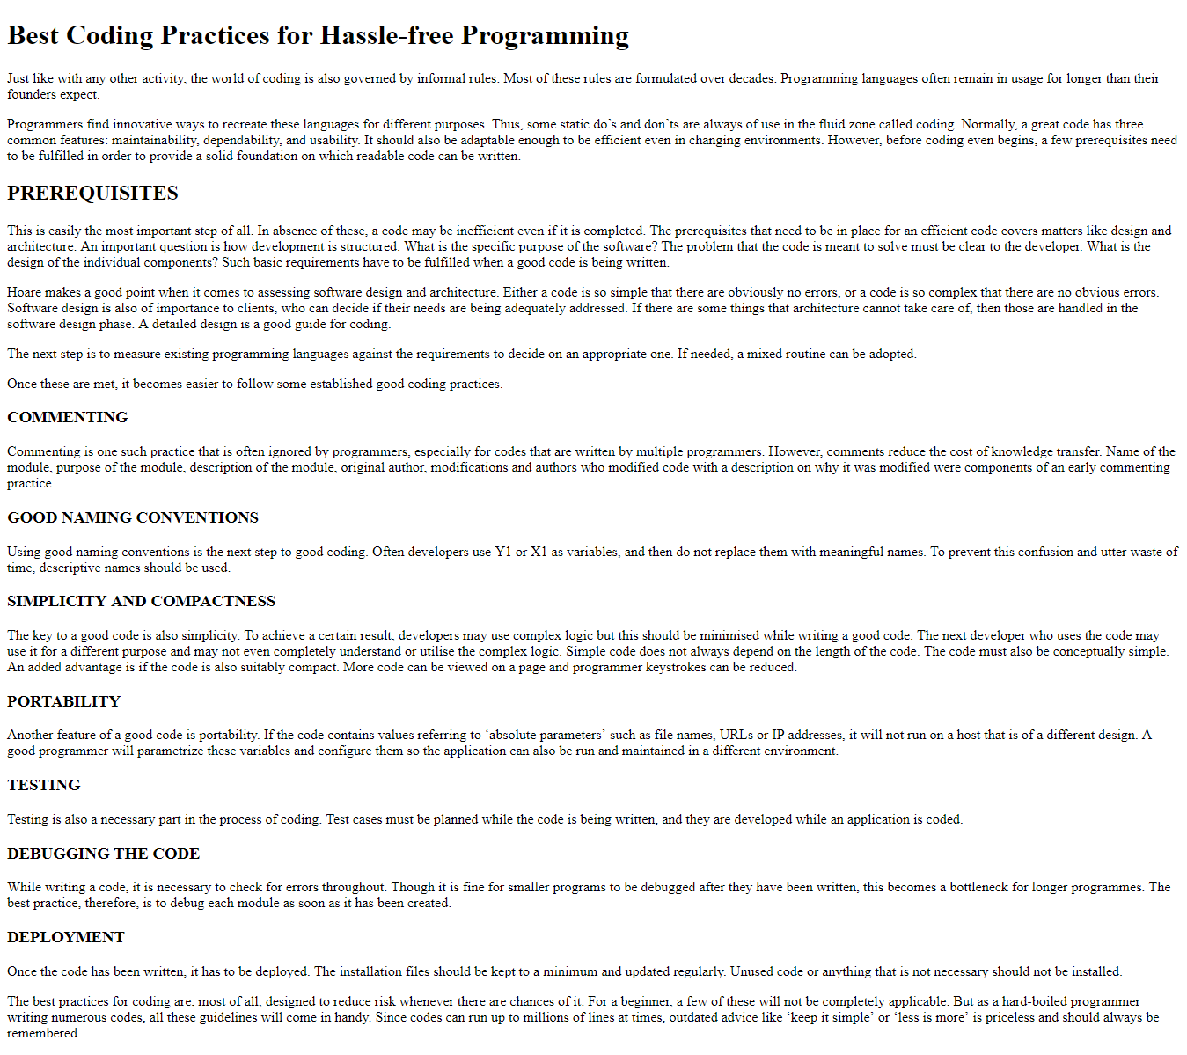](https://ninjasfiles.s3.amazonaws.com/0000000000001392.png)